

CSA0506-Database Management Systems

ASSESSMENT TOOL 2

Activity Tool : Concept Mapping (Medium)

Ashmi P S
192571004
1. Construct a concept map linking the following terms: DBMS,
Schema, Instance, Data Model, ER Diagram, Entity, Attribute,
Relationship.
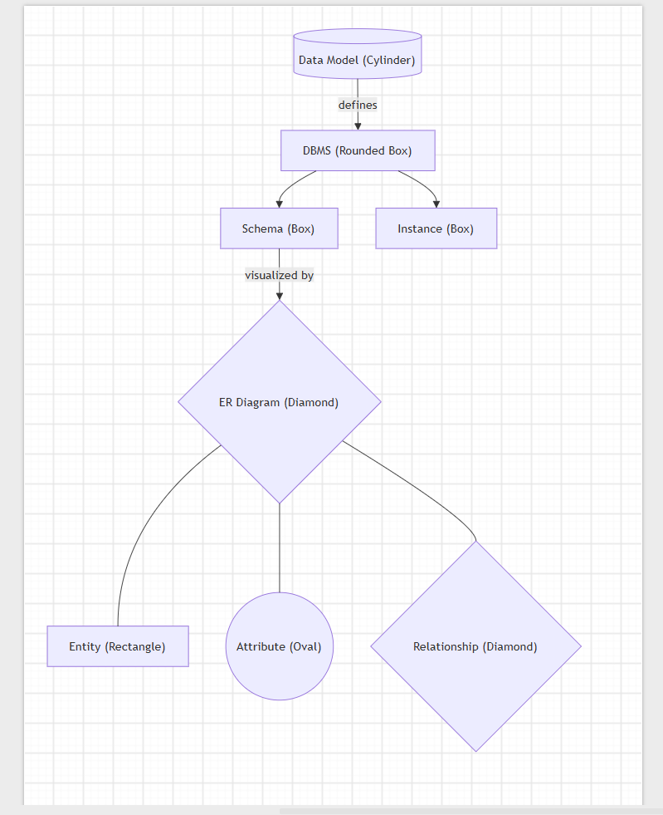
2.Create a concept map for the three-level ANSI/SPARC architecture
showing data independence at each level.
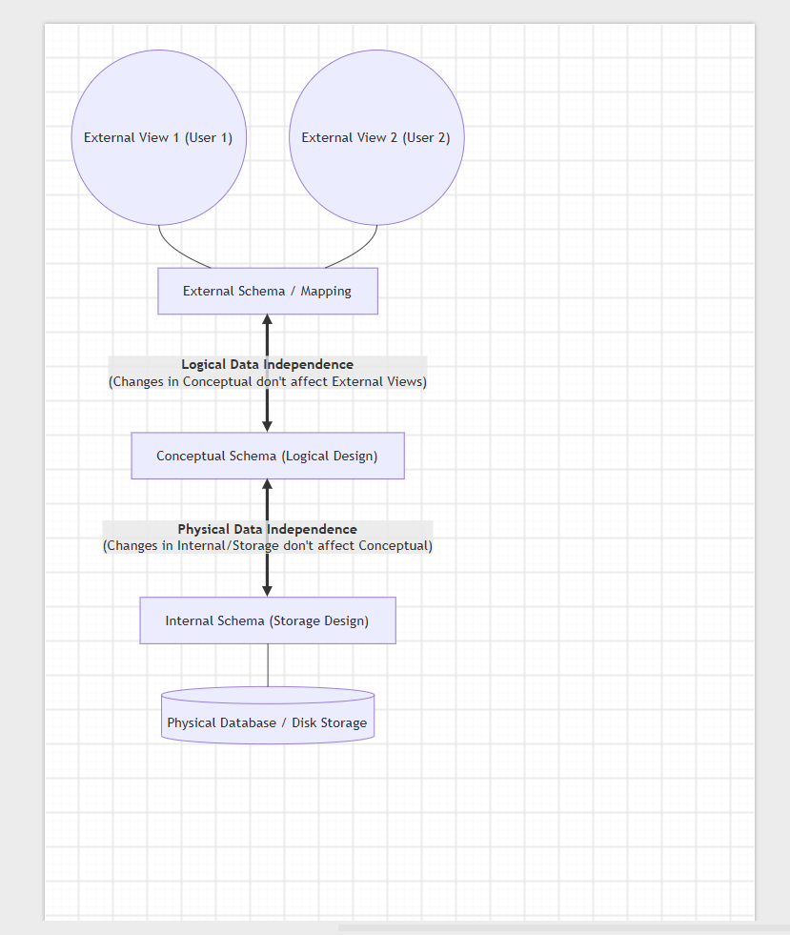
3. Map the relationship between file-based systems and database
systems, highlighting the problems solved by DBMS.
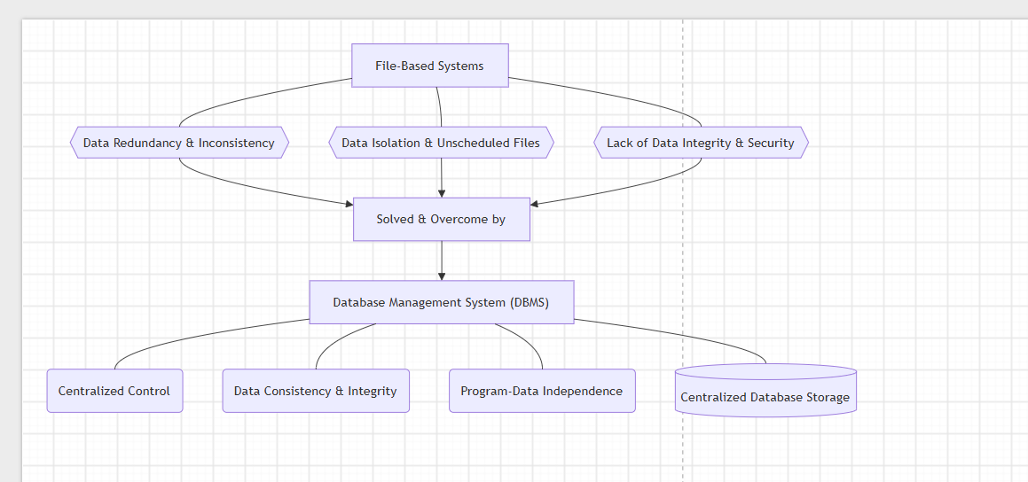

4. Design a concept map for ER diagram components: entity, weak
entity, attribute types, relationship types, and participation
constraints.

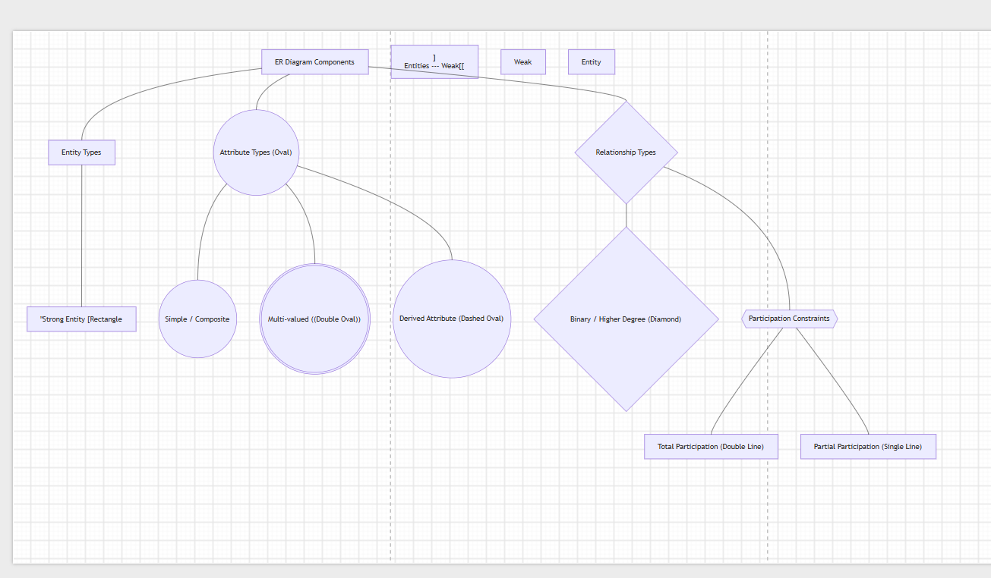

5 Construct a concept map comparing Hierarchical, Network, and
Relational data models with their key properties.
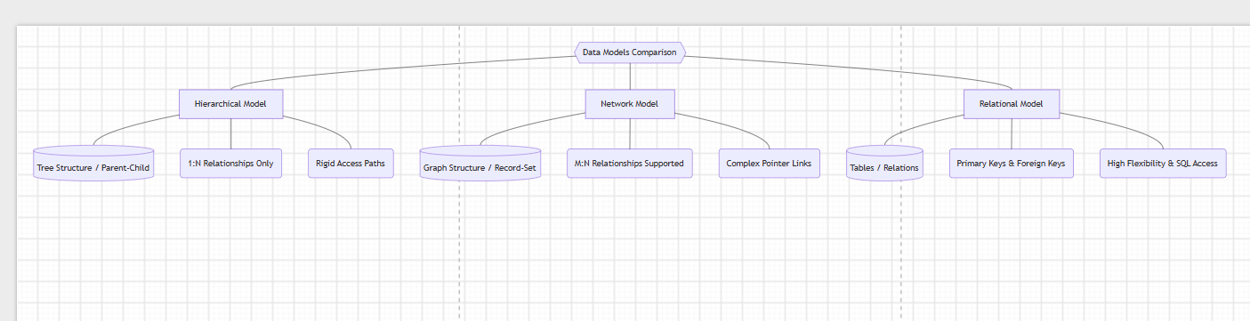

6. Develop a concept map for the EER model showing how it extends
the basic ER model with generalization, specialization, and
aggregation.
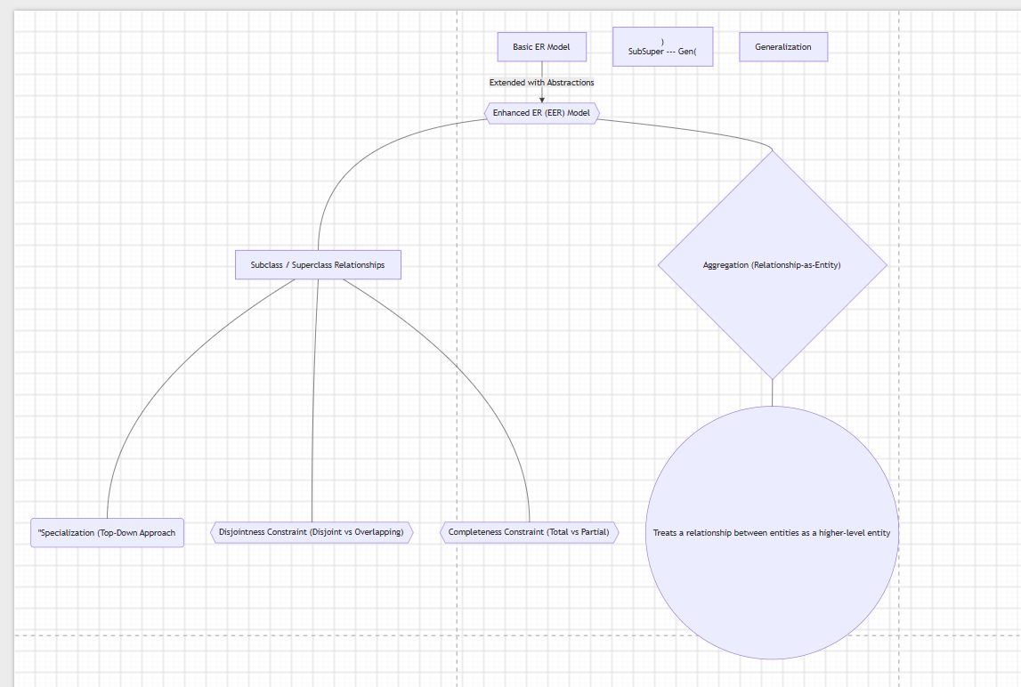

7 Create a visual concept map for the DBMS software architecture,
illustrating the flow from user request to data retrieval.
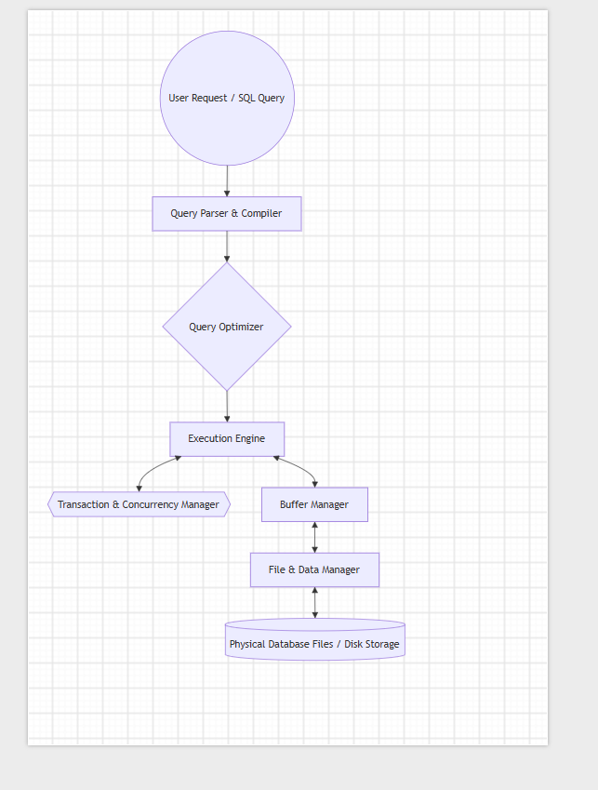

8. Map the data models discussed in CO1 to real-world applications
and explain the suitability of each model.

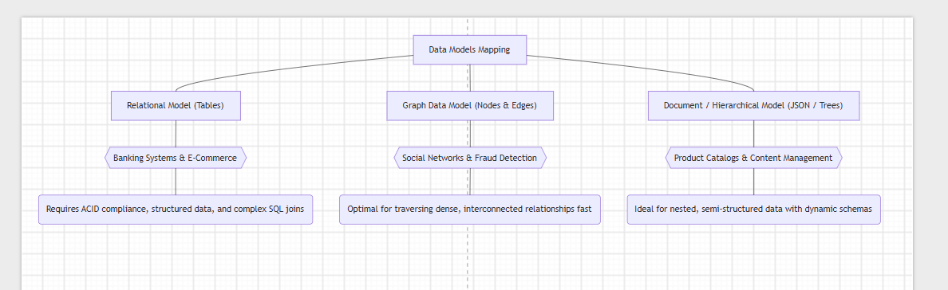

9. Construct a concept map for schemas and instances, showing how
they relate to physical and logical data independence.

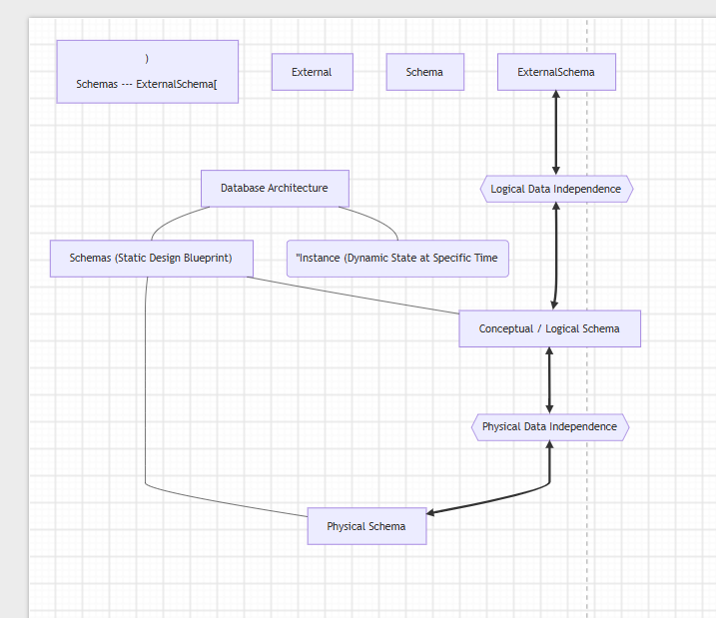

10. Design a concept map for the roles and responsibilities in a DBMS environment: DBA, End User, Application Developer.

